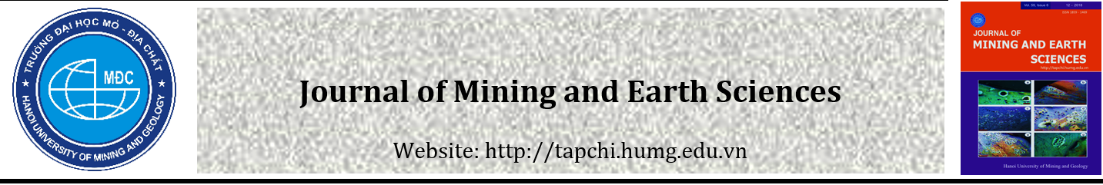
Type the title of your paper
First Author ^{1,*}, Second Author ²
¹ First affiliation address, City, Country
² Second affiliation address, City, Country

ARTICLE INFO |  | ABSTRACT
Article history:  Received 1st Feb 202x  Revised 2nd Mar 202x  Accepted 03rd Apr 202x |  | Abstract should be limited to 1 paragraph (should be no more than 300 words but not less than 250 words.) and convey the main points of the paper, outline the results and conclusions, and explain the significance of the results. Any inessential abbreviations (those personally invented, in particular), any formulas, references to bibliography, figures and/or tables are inadmissible in the abstract.  Font - Cambria; Style: Italic; Size: 11  Paragraph - Alignment: Justified; Before: 6pt; After: 6pt; Line spacing: Exactly 11  Copyright © 2020 Hanoi University of Mining and Geology. All rights reserved.
Keywords:
Please provide 5 keywords separated with comma.
(Font - Cambria; Style: Regular; Size: 10)

_____________________
*Corresponding author.
E-mail address: author@gmail.com
DOI: 10.46326/JMES.202x.xyz

1. Introduction
This template is an example for formatting a paper for the Journal of Mining and Earth Sciences. The template is available online at the page for authors on the official website of the Journal of Mining and Earth Sciences. Template should use the copy and paste function according to guide below.
The items are copied and pasted to the template as "Keep Text Only".
When you sit down and start writing your paper try to address as wide a reader as possible by using simple words, explain clearly as possible and provide sufficient explanatory material related to your research but do not exceed our laid down constraint of number of pages which is at most 12 pages including references for full-length article and 20 pages for review article.
Manuscripts for JMES should be submitted online at http://jmes.humg.edu.vn. The submitted manuscripts include 01 copy with the full name as the template file (Full manuscript) and 01 copy as the template with deleted information of authors, affiliation, acknowledgments, and contribution of authors (Blind).
Introduction section is the most important part of the format and must be included in any type of papers. It is the part where you introduce your line of research and to give the reason why you perused it (your research motivation), or you may also describe the work that was prior to your own (background of your work) but try not to make your description just as a list of references that tells nothing regarding the earlier work. Make your Introduction an informative summary of your paper that the reader can have an idea what he is going to find in the body of the paper.
The introduction must include these contents:
- The importance and the rationale of the study
- Identification of the researched matter and the aim of the research
- The issue that the research will discuss.

2. Literature Review (if relevant)
This part includes:
- Literature reviews of related studies and unresolved problems of those studies;
- Related theoretical bases, theoretical frameworks, or conceptual frameworks used in the research.
The manucript must be including text, references, and appendices. Microsoft Office (bằng .doc / .docx), paper size A4 (21 cm x 29,7 cm). Use Cambria font throughout the manuscript with size 11.

3. Research Methodology
Authors can submit a theoretical or empirical research, or a literature review paper; authors can adopt qualitative or quantitative analyses; or a mix of them.
The research methodology must show the quantitative model, qualitative hypothesis, and/or qualitative research design. Both the data collection process and data description must be specified.
Research papers published on the JMES include the following sections (respectively, however, it can be altered to fit each research paper). Main body of the article (font: Cambria, size 11).
The article should be divided into separate sections, each section is numbered clearly, in the order 1, 2, 3… If each section has smaller sections, they are numbered 1.1 respectively (( then 1.1.1, 1.1.2, ...), 1.2, etc.

3.1. Citations and references
3.1.1. Citations
Authors cite sources that are used as references only.
- For documents that have one author, only cite the surname of the author and publication year (Author name, publication year). Example: Nguyen (2021) or (Smith, 2021);
- For documents that have two authors, cite both of their surnames (First author’s name & Second author’s name, publication year). Example: Tran and Nguyen (2021) or (Smith and Brandel, 2021);
- For documents that have three or more authors, cite the surname of the first author then followed by “et al.” (First author’s name et al., Publication year). Example: Nguyen et al. (2021) or (Hair et al., 2014)
All references must be cited in the text and vice versa.
Authors list documents that are cited in the article text only. Regulations about how citations and references are presented are provided in Guidelines for citations and references.
3.1.2. References
References must be presented in APA 7th style and checked thoroughly for completeness, accuracy, and consistency. Documents in other languages must be written in that respective language.

3.2. Abbreviations and Acronyms
An abbreviation that is first introduced in the text. This abbreviation is placed within parentheses directly following its first occurrence of the spelled-out words in the text. Mostly, they are the initials of the words written in capital letters (e.g. Hanoi University of Mining and Geology (HUMG)). Thereafter, this abbreviation can be used instead of the words throughout the rest of the paper. However, try not to invent abbreviations just to save space, use words instead and make your paper more readable.
Abbreviations and acronyms are written either in capital letters or small letters depending on the way it has been originated; try to check a dictionary to be more certain.
3.2.1. Unit of measurement
Using the international system of units and standards (SI). If other systems of measurement are used, their correspondence should be converted to SI units.
3.2.2. Equations
The math formulas explained in the article, written in the Equation Editor, are numbered to the right of the margin. Parameters in formulas must be clearly defined and be italicied..
$$R=\frac{l}{σS}=\frac{2πr}{σπ{\left(\frac{D}{2}\right)}^{2}{10}^{-3}}\frac{N}{384} (1)$$
where: D - diameter (mm); σ - resistivity (S/m); r - average radius (mm); N - number of roll.
3.2.3. Figures
Figures, Charts, diagrams, and graphs in the document are uniformly labeled as Figure.
Tables and figures must be in high resolution and numbered separately and consecutively by Arabic numbers. , the number must be put behind the word “Figure” (for example Figure 1, Figure 2). Each figure must have a name that identifies the content of the figure. Figures should be included in the text.
The number and name of figures are put below the figure horizontally, in bold, and aligned left.
The source of the table is put under the name of the figure, aligned left.
The original Excel file is required if diagrams/graphs are created using Microsoft Excel.
Figures created by using Microsoft Word, Microsoft PowerPoint, Microsoft Excel, and Adobe Illustrator must be provided in their original format. Data collected from other applications should be copied to a new Microsoft Word file or saved and typed into a Microsoft Word document or saved as a PDF file.
Figures that cannot be provided in the aforementioned format can be submitted in standard image formats:
- EPS (or PDF): vector drawing. save characters as a graphics
- TIFF (or JPG): color or grayscale image, use at least 300 dpi
- TIFF (or JPG): drawings with lines/strokes, using a resolution of at least 1000 dpi.
- TIFF (or JPG): composite drawing including images and lines, using a resolution of at least 500 dpi.

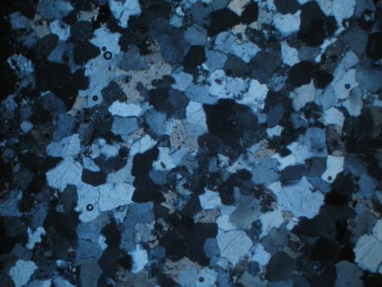
Figure1. This figure depicts a high-resolution color image of a still from an animation about brain cells as an examples of TIFF files

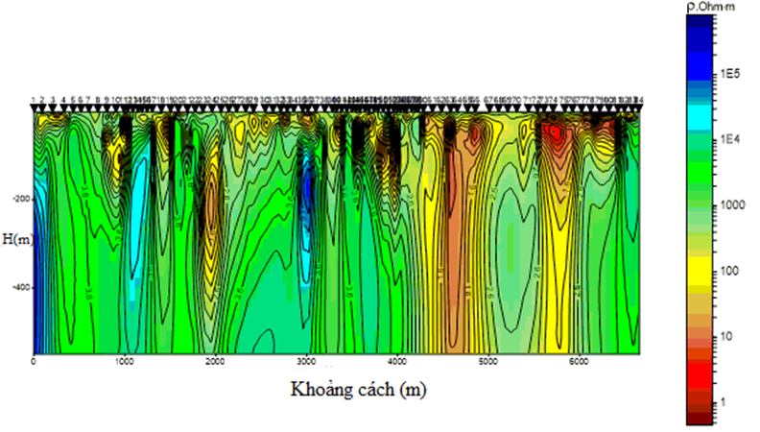
Figure 2. Image resolution use at least 300 dpi.

3.2.4. Tables
Tables should be well structured and organized to attract the interest of readers in your work as they can easily be understood without referring to the text. They are often used for reporting extensive numerical data that have been, for example, obtained from conducting multiple experiments and cannot be presented in a graph.
Table title (caption) should be brief, clear, and descriptive but sufficiently explained the data included, as such they can be lengthy or short depending on the topic of the paper. Captions for tables are placed above the table (center aligned).
Column titles (headings) normally used to simplify the table and describing the material below it that help the reader to quickly understand what the table is presenting. Column headings are centered over the columns of numerical data
The body of the table is usually a group of rows and columns of data. Center-align this data within the body of the table and make it neat and clear by giving plenty of space. Sometimes things seem complicated if the rows and columns need to be grouped or subdivided, in this case, there should be a row or column subheadings.

Table 1. Water samples and analytical methods
No | Parameters | Units | Method of analysis
1 | pH | - | Quick test by TOA WQC - 22A
2 | Dissolved oxygen (DO) | mg/l
3 | Total suspended solid (TSS) | mg/l | TCVN 6625 - 2000
4 | Chemical oxygen demand (COD) | mg/l | TCVN 6491 - 1999
5 | Biological oxygen demand after 5 days at 20⁰C (BOD₅) | mg/l | TCVN 6001 - 1995
6 | Ammonium (NH₄⁺ - N): | mg/l | TCVN 5988 - 1995
7 | Phosphorus (PO₄³ ⁻ - P) | mg/l | TCVN 6494 - 1999
8 | Total Coliform | MPN/100ml | TCVN 6187 - 1:1996

4. Results and Discussions
This part should:
- Explain and analyze the results of the research thoroughly;
- Discuss and find out how the results are related to former studies’ findings.

5. Conclusions and/or Recommendations
Depending on the purpose of the study, provide conclusions, based on the results of the research.
Limitations and potential research ideas (if any) should be included in this part.

6. Acknowledgement: if applicable
It is the proper section in the paper to thank all the people who helped you most in carrying out your research work. For example, a supervisor, a sponsoring institution, a funding body, and your colleagues or other researchers who have helped in the preparation and agreed to share with you their unpublished results. Acknowledge people’s help and contribution will ensure the integrity of your research. It is also worth remembering that the style of writing the acknowledgement should be in a professional manner, so try to avoid any emotional or personal thoughts.

7. Contributions of authors
Nguyen Van A - methodology, writing, review & editing; Tran Van B - writing, review & editing, supervision.

8. References
* Paper published in journal
Hoxha, D., & Homand, F. (2000). Microstructural approach in damage modelling. Mechanics of Materials, 32(3), 377-387.
Le, V. C., Cao, X. C., & Le, T. T. H. (2020). Research on optimal takeoff positions of UAV intergrated GNSS-RTK in producing large scale topological maps for open - pit mines. Journal of Mining and Earth Sciences, 60(05), 54-63. (in Vietnamese).
* Presentation at conferences
Hoxha, D. F., & Homand, F. (2008). Microstructural approach in damage. The 2nd international conference on dynamics and control. January 23-26. Japan, 377-387.
Bui, T.K.T., & Nguyen, M.C. (2019). Establish 3D model from UAV and TLS data. Annual scientific conference 2019. Thuy Loi university, ISBN: 978-604-82-3869-8.
* Book
Dang, T. T., & Dang, V. Q. (2018), Reinforcement of soil and rock and construction of underground construction in special conditions. Construction Publishing House, Hanoi, 82 pp. (in Vietnamese).
Newman, B., (2015). Theory of elasticity and applications. Springer. New York, 438 pages
* Other archived or unpublished documents:
Adam, L. (2019), Effect of A on B, Master thesis, University of ABC, Hanoi, Vietnam.
Tran, V. K. (2017). Improve the quality of higher education. PhD Thesis, University of Mining – Geology, Hanoi, Vietnam. 313 pp. (in Vietnamese).
Adhiri, P. H., 1990. Physio-morphological responses of upland rice to shade. PhD Dissertation, University of the Philippines Los Banos, Philippine. 250 pp.
* Website:
If available, the URL must be provided at the end of the reference, as well as the accessing date.
Newman, B., 2015. Theory of elasticity and applications. Springer, New York, 438 pages.

